LAB EXPERIMENT NO # 14
Name: __________________________________ Date: ________________________
Score: __________________________________Signature of Instructor___________
DIODE CLIPPER CIRCUITS
PERFORMANCE OBJECTIVE:
- To demonstrate the function of clipper circuits.
EQUIPMENT:
- Oscilloscope
- Digital Multi Meter
COMPONETNTS:
- Electrical Circuit Kit
- A bread board
- IN4001 diodes
- 1-KΩ resistor
- Few connecting wires

THEORY:
Clippers are networks which clip away part of the applied signal. Clippers are used to create a specific type of signal and to limit the voltage that can be applied to a network. Clipper circuit consists of AC-source, diode and DC-Source ( to shift the operating point to the required value). A circuit which removes the peak of a waveform is known as a clipper. A negative clipper is shown in figure 7-1.
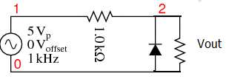
Fig.7-1. Negative clipper clips peak at 0.7 v
During the positive half cycle of the 5 V peak input, the diode is reversed biased. The diode does not conduct. It is as if the diode were not there. The positive half cycle is unchanged at the output V (2) in Figure 7-2. Since the output positive peaks actually overlays the input sinewaveV (1), the input has been shifted upward in the plot for clarity. V(1)+1 is actually V(1), a 5 Vp-p sine wave, offset by 1 V for display clarity. V (2) output is clipped at -0.7 V, by diode D1.
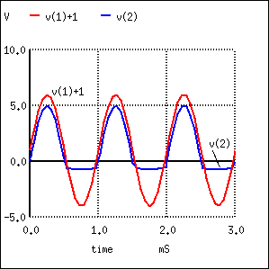
Fig. 7-2: Negative peak of input clipped off
During the negative half cycle of sine wave input of Figure 7-2 the diode is forward biased, that is, conducting. The negative half cycle of the sine wave is shorted out. The negative half cycle of V(2) would be clipped at 0 V for an ideal diode. The waveform is clipped at -0.7 V due to the forward voltage drop of the silicon diode. Germanium diode clip at lower voltages.
Closer examination of the negative clipped peak (fig 7-2) reveals that it follows the input for a slight period of time while the sine wave is moving toward -0.7 V. The clipping action is only effective after the input sine wave exceeds -0.7 V. The diode is not conducting for the complete half cycle, though, during most of it.
The addition of an anti-parallel diode to the existing diode in Figure 7-1 yields the symmetrical clipper in Figure 7-3.
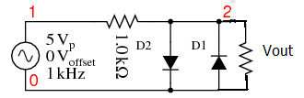
Fig.7-3: Symmetrical clipper: Anti-parallel diodes clip both positive and negative peak, leaving a ± 0.7 V output.
Diode D1 clips the negative peak at -0.7 V as before. The additional diode D2 conducts for positive half cycles of the sine wave as it exceeds 0.7 V, the forward diode drop. The remainder of the voltage drops across the series resistor. Thus, both peaks of the input sine wave are clipped in Figure 7-4
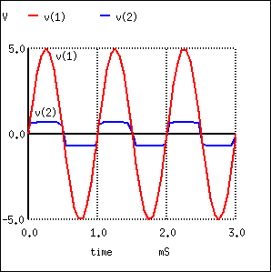
Fig.7-4: Diode D1 clips at -0.7 V as it conducts during negative peaks. D2 conducts for positive peaks, clipping at 0.7V.
The most general form of the diode clipper is shown in Figure 7-5. For an ideal diode, the clipping occurs at the level of the clipping voltage, V1 and V2. However, the voltage sources have been adjusted to account for the 0.7 V forward drop of the real silicon diodes. D1 clips at 1.3V +0.7V=2.0V when the diode begins to conduct. D2 clips at -2.3V -0.7V=-3.0V when D2 conducts.
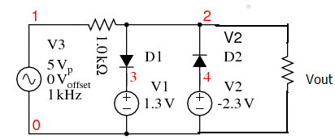
Fig.7-5: D1 clips the input sine wave at 2V. D2 clips at 3v
The clipper in Figure 7-2 does not have to clip both levels. To clip at one level with one diode and one voltage source, remove the other diode and source.
The waveforms in Figure.7-6 show the clipping of V (1) at output V (2).
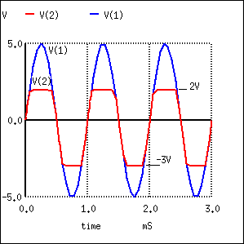
Fig.7-6: D1 clips the sine wave at 2V. D2 clips at -3V.
A practical application of a clipper is to prevent an amplified speech signal from overdriving a radio transmitter in Figure 7-7. Over driving the transmitter generates spurious radio signals which cause interference with other stations. The clipper is a protective measure.
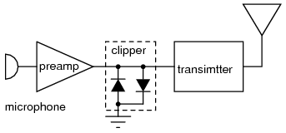
Fig.7-7: Clipper prevents over driving radio transmitter by voice peaks.
A sine wave may be squared up by overdriving a clipper. Another clipper application is the protection of exposed inputs of integrated circuits.
PROCEDURE:
- Make the connections as shown in fig. 7-1, 7-3 and 7-5.
- Connect the input 1KHZ, 5Vp sine wave to the circuits.
- Observe the input and output waveforms by oscilloscope at load resister of each of the circuit.
- Draw these waveforms here.

Fig: 7-1 O/P Waveform Fig: 7-3 O/P Waveform Fig: 7-5 O/P Waveform

REVIEW QUESTIONS:
- What do you mean by clippers?
________________________________________________________________________________________________________________________________________________

- What are the practical applications of diode clippers?
________________________________________________________________________________________________________________________________________________

- Why we add the DC source in series with diodes in clipper circuit?
________________________________________________________________________________________________________________________________________________

- What will be the output waveform of fig 7-1 if we consider the ideal diode?
________________________________________________________________________________________________________________________________________________

LAB EXPERIMENT NO # 14
Name: __________________________________ Date: ________________________
Score: __________________________________Signature of Instructor___________
DIODE CLAMPER CIRCUITS
PERFORMANCE OBJECTIVE:
- To demonstrate the function of clamper circuits.
EQUIPMENT:
- Oscilloscope
- Digital Multi Meter
COMPONETNTS:
- Electrical Circuit Kit
- A bread board
- IN4001 diodes
- 1-KΩ resistor
- Few connecting wires

THEORY:
Clampers or DC restorers are networks that clamp the input signal to a different dc level, but the peak-to-peak swing of the applied signal will remain the same. Clamper circuit consists of clipper components plus a series capacitor. A clamper is an electronic circuit that prevents a signal from exceeding a certain defined magnitude by shifting its DC value. A diode clamp relies on a diode, which conducts electric current in only one direction; resistors and capacitors in the circuit can be used to alter the dc level at the clamper output.
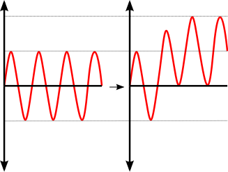
Fig-8.1 Positive unbiased voltage clamping shifts the amplitude of the input waveform so that all parts of it are greater than 0V

TYPES:
Clamp circuits are categorized by their operation; negative or positive and biased and unbiased. A positive clamp circuit outputs a purely positive waveform from an input signal; it offsets the input signal so that all of the waveform is greater than 0V. A negative clamp is the opposite of this .This clamp outputs a purely negative waveform from an input signal. A bias voltage between the diode and ground offsets the output voltage by that amount.
For example, an input signal of peak value 5V (V_{IN} = 5V) is applied to a positive clamp with a bias of 3V (V_{BIAS} = 3V), the peak output voltage will be
V_{OUT} = 2V_{IN} + V_{BIAS}
V_{OUT} = 2 * 5 + 3
V_{OUT} = 13V

POSITIVE UNBIASED:
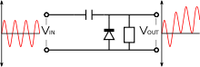

Fig.8-2.A positive unbiased clamp
In the negative cycle of the input AC signal, the diode is forward biased and conducts, charging the capacitor to the peak positive value of V_{IN}. During the positive cycle, the diode is reverse biased and thus does not conduct. The output voltage is therefore equal to the voltage stored in the capacitor plus the input voltage again, so V_{OUT} = 2V_{IN}
NEGATIVE UNBIASED:
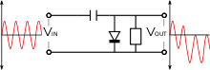

Fig.8-3.A negative unbiased clamp
A negative unbiased clamp is the opposite of the equivalent positive clamp. In the positive cycle of the input AC signal, the diode is forward biased and conducts, charging the capacitor to the peak value of V_{IN}. During the negative cycle, the diode is reverse biased and thus does not conduct. The output voltage is therefore equal to the voltage stored in the capacitor plus the input voltage again, so V_{OUT} = -2V_{IN}
POSITIVE BIASED:
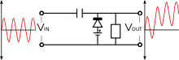

Fig.8-4.A positive biased clamp
A positive biased voltage clamp is identical to an equivalent unbiased clamp but with the output voltage offset by the bias amount V_{BIAS}. Thus, V_{OUT} = 2V_{IN} + V_{BIAS}
NEGATIVE BIASED:
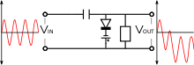

Fig.8-5.A negative biased clamp
A negative biased voltage clamp is likewise identical to an equivalent unbiased clamp but with the output voltage offset in the negative direction by the bias amount V_{BIAS}. Thus, V_{OUT} = -2V_{IN} - V_{BIAS.}
PRINCIPLES OF OPERATION:
The schematic of a clamper reveals that it is a relatively simple device. The two components creating the clamping effect are a capacitor, followed by a diode in parallel with the load. The clamper circuit relies on a change in the capacitor’s time constant; this is the result of the diode changing current path with the changing input voltage. During the first negative phase of the AC input voltage, the capacitor in the positive clamper charges rapidly. As the Vin becomes positive, the capacitor serves as a voltage doublers; since it has stored the equivalent of Vin during the negative cycle, it provides nearly that voltage during the positive cycle; this essentially doubles the voltage seen by the load. As the Vin becomes negative, the capacitor acts as a battery of the same voltage of Vin. The voltage source and the capacitor counteract each other, resulting in a net voltage of zero as seen by the load.

BIASED VERSUS NON-BIASED:

By using a voltage source and resistor, the clamper can be biased to bind the output voltage to a different value. The voltage supplied to the potentiometer will be equal to the offset from zero (assuming an ideal diode) in the case of either a positive or negative clamper (the clamper type will determine the direction of the offset. If a negative voltage is supplied to either positive or negative, the waveform will cross the x-axis and be bound to a value of this magnitude on the opposite side. Zener diodes can also be used in place of a voltage source and potentiometer.

CLAMPER APPLICATIONS:
Clamping can be used to adapt an input signal to a device that cannot make use of or may be damaged by the signal range of the original input.
A clamping circuit (also known as a clamper) will bind the upper or lower extreme of a waveform to a fixed DC voltage level. These circuits are also known as DC Voltage restorers. Clampers can be constructed in both positive and negative polarities. When unbiased, clamping circuits will fix the voltage lower limit (or upper limit, in the case of negative clampers) to 0 Volts. These circuits clamp a peak of a waveform to a specific DC level compared with a capacitive coupled signal which swings about its average DC level (usually 0V).
PROCEDURE:
- Make the connections as shown in fig. 8-2, 8-3, 8-4 and 8-5.
- Connect the input wave 1 KHZ, 5Vp-p sine wave to the circuits.
- Observe the input and output waveforms by oscilloscope at load resister of each of the circuit.
- Draw these waveforms here.
Fig: 8-2 O/P Waveform Fig: 8-3 O/P Waveform
Fig: 8-4 O/P Waveform Fig: 8-5 O/P Waveform

REVIEW QUESTIONS:
- What do you mean by clampers?
________________________________________________________________________________________________________________________________________________

- What are the practical applications of diode clampers?
________________________________________________________________________________________________________________________________________________

- Why we add the DC source in series with diodes in clamper circuit?
________________________________________________________________________________________________________________________________________________

- What will be the output waveform of fig 8-2 if we consider the ideal diode?
________________________________________________________________________________________________________________________________________________

